**ASSIGNMENT 1**

**STUDENT ID: 1013239 & 1012861**

***QUESTION 1***

By trying both macro and micro averaging, we found that there is a higher precision, recall, and f-score value when using the micro averaging method. This is because macro averaging takes the average precision and recall values of each class while micro averaging sums the true positives of each instance in a class and divides that by the sum of the true positives and false positives, to get precision, or false negatives, to get recall. This causes the precision and recall value of micro-averaging to also be equal since theoretically every false positive of a class will be a false negative of another class. Macro-averaging shows a lower result than micro-averaging due to class imbalances which means that each value is treated equally where there are cases where a class only contains a smaller number of instances compared to another (e.g. ‘mountain’ class has 160 instances where ‘seatedforwardbend’ class only has 42 instances).

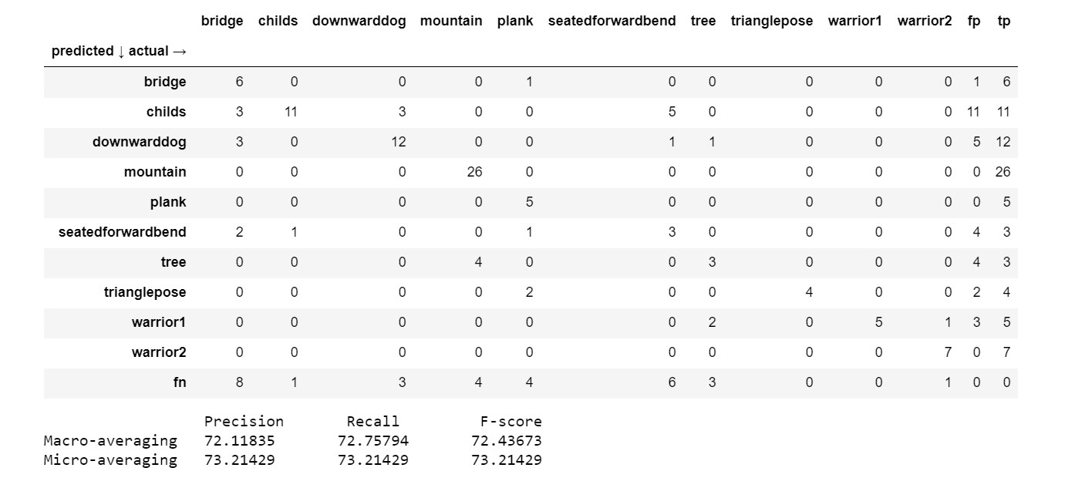

***QUESTION 3***

For the kernel bandwidth, we chose to use 10 since there are also 10 different classes in the dataset. The accuracy obtained through the Gaussian naïve Bayes implementation was 73% while in the KDE implementation we got an increase in accuracy with 75%. This increase in accuracy might suggest that some of the data does not follow a Gaussian distribution, and hence the assumption that it does is false leading to lower accuracy values. The predicted classes obtained from the KDE implementation is 76.8% similar to the one obtained by the Gaussian distribution. From calculating the values of false positives and negatives obtained from the KDE implementation, we can see that there is a decrease in the number of false positives for some attributes such as ‘childs’ however an increase in the number of false positives for other attributes such as ‘bridge’. This suggests that attributes such as ‘childs’ do not follow a Gaussian distribution while attributes like ‘bridge’ can said to follow a Gaussian distribution.

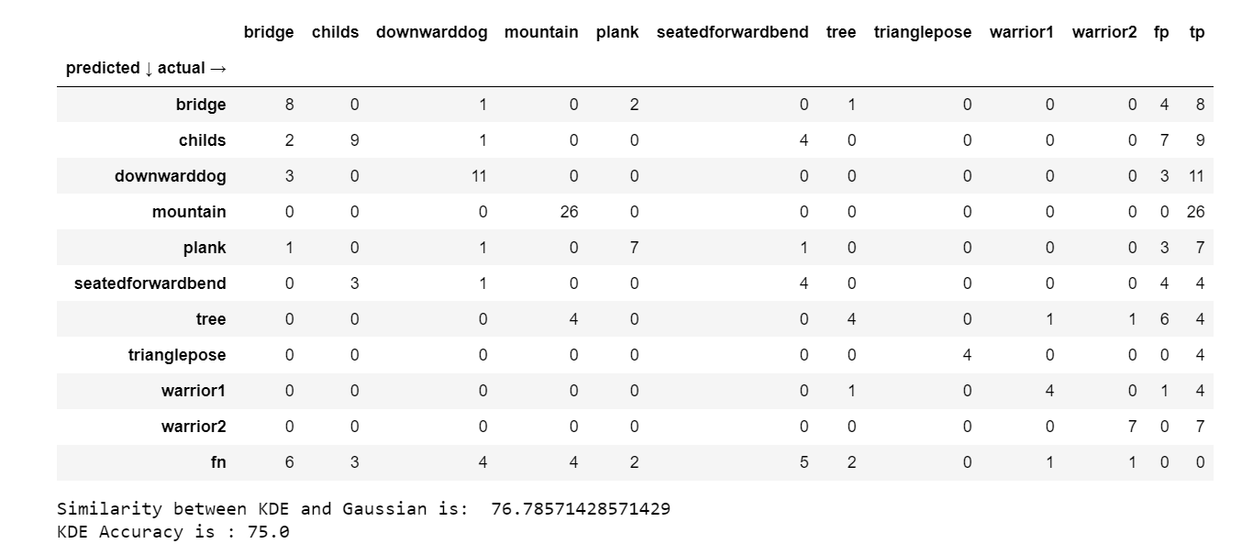

***QUESTION 4***

In this questions, we use cross-validation to choose the kernel bandwidth. We split the training data into 8 partitions to depict the ratio of the actual training dataset : test set of 747 : 116 ≈ 7 : 1. Within each partition, we try different kernel bandwidths of 5,10,15,20,25 from the recommended 5-25 range, where we will choose the kernel which results in the highest accuracy. Once KDE Naïve Bayes is done using different kernel bandwidths within each partition, we take the average of the best bandwidths chosen. We will then perform KDE Naïve Bayes on the actual test dataset using the averaged kernel bandwidths.

Our cross validation for choosing kernel bandwidths chose the best bandwidth by choosing the bandwidth which results in the highest accuracy and our implementation found that 5.0 is the best kernel bandwidths width accuracy of 77.68% compared to using the chosen arbitrary kernel bandwidth of 10 in which accuracy is 75%. As can be seen from the graph below for class bridge with x1 vs its KDE, when bandwidth = 5 (red), more peaks can be seen when compared to bandwidth = 5 (blue) which results in better generalisation of the classes.

***QUESTION 5***

Here, we use mean imputation to replace the missing values in certain attributes. However, we found that despite this makes the mean of the class higher and less skewed due to the 0-imputation method we initially used, the accuracy is exactly the same as if the missing values is ignored. When we tried to input it into the KDE classifier, it shows a significant decrease in accuracy, from 75% to 69%. This might suggest that the mean-imputed data is closer to resembling a Gaussian distribution instead of an unknown distribution hence allowing the accuracy of the Gaussian Naïve Bayes classifier to stay the same but showing a reduction in accuracy for the KDE classifier. This data suggest that missing values are useful in this task and that it should be left empty instead of trying to impute it with mean values. This is because sometimes missing values are intentional, to indicate that the hand is placed there to complete the pose and hence the data should not be altered.

